|  |  |
| --- | --- |
| Name of the student: Léa SENGHOR | Name of your Level 1: SELVINA GOVINDEN |
| Source: [Science Direct](https://www.sciencedirect.com/science/article/pii/S2405896323017615) | Paper title End-to-end process monitoring: Challenges and framework for case study design |
| Keywords speci1c to the paper: | process monitoring; fault detection, identification, and diagnosis process recovery |

# Introduction: Introducing end-to-end process monitoring (E2E-PM)

|  |
| --- |
| E2E-PM (End-to-end process monitoring): |

Algorithms with the ability to detect, execute, identi1y and

diagnose faults in order to generate interventions for process recovery.

For example: along one of Amazon's supply chains, sensors have been installed to ensure that everything

is running smoothly. If there's a problem, such as a package that can't be scanned, the system automatically detects it.

1. Traditional monitoring methods: Monitor only 1 or 2 aspects s
2. E2E-PM: Automatically links tasks to initiate recovery actions and prevent failures

⇒ Process monitoring with E2E-PM ensures that interventions are made at the right time to reduce the long-term adverse eIects of failures and ensure long-term process optimization.

# E2E-PM Challenges

3 main de1s:

1. Di!culty of diagnosis: In practice, faults are di!cult to identi1e, so intervention is delayed.
2. Lack of literature in existing case studies: Existing case studies provide little information about the interventions available. This makes it difficult to diagnose the exact problem.
3. Optimization of performance measurements limited: It is easier to diagnose certain aspects of the system that are easy to monitor (e.g. fault detection) than other aspects that are necessary to maintain the system's operability, which keeps the whole system functional.

For example: At Amazon, it's easier to diagnose slowness in the production chain.

rather than the wear and tear of a machine part on the production line

# Enhancing existing case studies with E2E-PM

|  |
| --- |
| Constant monitoring: |

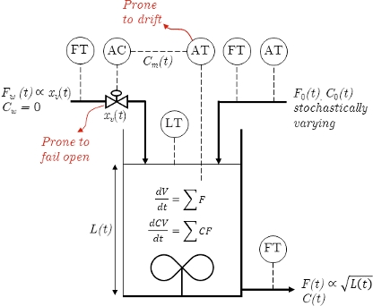Conceptual framework for current case studies: A large water mixing tank is present in a company:

1. The tank receives water + a yellow dye where the flow rate and quantity of dye are constantly changing.
2. The aim is to keep the same amount of water and colorant regardless of the flow rate.
3. A failure is always possible: e.g. the sensor measuring the of sugar may no longer display the exact amount

the company uses a system known as in-process

analysis.

principal components (PCA) is used for detection and has been trained using data from the first seven days.

|  |
| --- |
| Interpretation: |

This example provides a simplified way of showing and understanding the monitoring

process for the various components and the relationships between them.

Limitations of case studies: Variability of disturbances

* Importance of designing case studies that reRect the de1s of practical process monitoring
* Simulations in case studies present only two iterative variations where in practice (e.g. in an industry), processes face multiple possible disturbances (e.g. fluctuation of demand, production intensity, slowness due to a defective part, shortages in raw material).

# Conclusion

* Quality of process monitoring: The faster the intervention and diagnosis of faults, the greater the impact on the efficiency of process monitoring. In addition, efficiency will have a positive impact on environmental, safety and 1nancial criteria.
* Relevance of using E2E-PM solutions: The E2E-PM framework seeks to improve process monitoring techniques through the use of mechanisms for feasible, rapid, optimal interventions and adapted performance criteria, while taking into account process variability.
* Interpretation of the case studies: A plant functions optimally in economic terms when it is able to detect and diagnose faults quickly and efficiently.
* Possible improvements for future articles: the main challenge1 lies in the complexity of the framework in the face of rapid developments and constant variations. Future articles should therefore focus on specific and targeted dimensions of monitoring systems, as well as on the use of reinforcement learning, which could bring new results.